**Appendix F**

**F.1.0 NASA SMD Computational and Information Sciences and Technology Office (CISTO)**

**POCs:** James Harrington, [james.l.harrington@nasa.gov](mailto:james.l.harrington@nasa.gov) 301-286-4063

Elizabeth A. Macdonald, [elizabeth.a.macdonald@nasa.gov](mailto:elizabeth.a.macdonald@nasa.gov), 301-286-6690

**F.1.1.** **Program** Computational and Information Sciences and Technology Office (CISTO) Computational and Technological Advances for Scientific Discovery via AI/ML Modeling and Development implementing an open science approach.

NASA open science promotes the availability of original source code and data to be available on the public domain to be repurposed for easier collaborations to be born among different groups or teams to work towards solving scientific problems that can benefit society.

NASA SMD communicates a VISION via the SMD Big Data Working Group (SBDWG) to enable transformational open science through continuous evolution of science data and computing systems for NASA’s Science Mission Directorate. SMD requests that NASA EPSCoR include research opportunities for data analysis that provide tools and training to diverse communities to be better able to collaborate with all types of computational and computer scientists that enables the funding of successful collaborations, including Artificial Intelligence and Machine Learning (AI/ML).

The SBDWG report states that “SMD and the individual science divisions do not operate in isolation and therefore should recognize there is tremendous value in engaging with multiple stakeholder groups to identify opportunities to increase collaboration and use of advanced tools and techniques to drive scientific discovery. The decisions on when and how to collaborate should be made in such a way that SMD sets policies and facilitates sharing best practices, while providing the science divisions with responsibility and flexibility to manage their systems to meet the needs of their communities.

One such strategy to support this VISION is promoting a robust Citizen Science program recommended by the SMD Science Management Council approved by the SMD Associate Administrator. SMD citizen science projects shall be held to the same rigorous standards as any SMD science program. Documented project goals must include advances in science, the merit of which shall be determined by peer review.

Additionally, the SBDWG report communicates a goal to: Continuously Evolve Data and Computational Systems **-** SMD must therefore continuously evolve data and computational systems to realize the potential of innovative techniques to more efficiently manage data and computing resources and establish policies optimized to support investments in technology development and adoption. This will require investments in data systems, computational approaches, and the workforce that harnesses technology are needed to support the evolution of data management and computing systems.

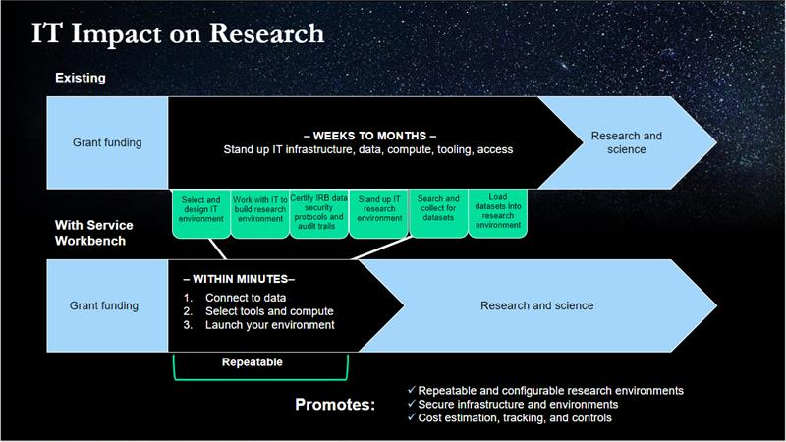

This Appendix opportunity is designed to facilitate the continuous progress towards the SMD goals for open science via targeting data analysis opportunities for Heliophysics Citizen Science, one of the SMD Science Themes to increase science returns that are to be held to the same rigorous standards as any SMD science program while facilitating advancements in agency resources for continuously optimizing techniques and computing resources for more efficient data science research. An additional responsiveness component is for broadening participation of underrepresented audiences.

Broadening Participation of traditionally underrepresented audiences

Former NASA Administrator James Bridenstine communicated a diversity agenda for the agency that is continued today: “We embrace the critical importance of cultivating and empowering a diverse and inclusive workforce and work environment-enabling NASA to attract the widest and deepest pools of talent, leverage the capabilities of our exceptional workforce; and empower all personnel to be authentic, to participate, and to fully contribute. We understand this provides NASA access to the highest levels of knowledge, capabilities, creativity, problem solving, decision making, and performance. And this will enable NASA to achieve the greatest mission success.”

A proposal that is fully responsive to this opportunity must establish a research, education, training and capacity building collaboration strategy that includes:

1. Majority/Minority lead institution partners with MSI (HBCU, HSI, Tribal College) within EPSCoR jurisdiction or across another EPSCoR jurisdiction;
2. Majority/Minority lead institution partners with a Community College within EPSCoR jurisdiction or across another EPSCoR jurisdiction;
3. Majority/Minority lead institution partners with another Majority/Minority institution with a focus on including ethnic minority students.

Or some type of mixture of any of the three.

**NASA Contact:**

a. Name: James Harrington

b. Organization: NASA Goddard Space Flight Center

c. Work Phone: 301-286-4063

d. Email: james.l.harrington@nasa.gov

**F.1.2:** Supporting Heliophysics Citizen Science Goals through Data Partnerships

**POC:** Elizabeth MacDonald, [elizabeth.a.macdonald@nasa.gov](mailto:elizabeth.a.macdonald@nasa.gov), 505-920-7602

1) Program: Artificial Intelligence and Machine Learning Capability

2) Research Title: Supporting Heliophysics Citizen Science Goals through Data Partnerships

3) **Research Overview:**

The Science Mission Directorate Heliophysics Division studies the nature of the Sun, and how it influences the very nature of space — and, in turn, the atmospheres of planets and the technology that exists there. Space is not, as is often believed, completely empty; instead, we live in the extended atmosphere of an active star. Studying this system not only helps us understand fundamental information about how the universe works, but also helps protect our technology and astronauts in space. NASA seeks knowledge of near-Earth space, because -- when extreme -- space weather can interfere with our communications, satellites and power grids. The study of the Sun and space can also teach us more about how stars contribute to the habitability of planets throughout the universe.

Citizen science in Heliophysics has a balanced strategy and implementation plan that maximizes natural opportunities over the next five years. Our Vision is to leverage public participation in Heliophysics to help drive innovation and diversity in science, society, and education and our Mission is to build a robust, dynamic, and engaging Heliophysics citizen science portfolio that fuses natural phenomena, mission opportunities, and the power of people’s diverse viewpoints to fuel collective innovation. To achieve our Mission, a number of inter-related Objectives build momentum towards our goals to Grow, Execute, Innovate, Communicate, Optimize, and Partner. There is an opportunity to achieve this vector of opportunities in our strategic plan to its fullest implementation and we look forward to pursuing this here. We are looking to advance this Vision by building new partnerships and capacity between existing citizen science projects, achieving our vision and the data science interest of this call. More about our strategy can be found here: https://science.nasa.gov/heliophysics/programs/citizen-science.

4) **Research Focus:**

Citizen Science programs are a form of open collaboration in which individuals or organizations participate voluntarily in the scientific process. The current SMD Policy (<https://smd-prod.s3.amazonaws.com/science-red/s3fs-public/atoms/files/SPD%2033%20Citizen%20Science.pdf>) on citizen science describes standards for evaluating proposed and funded SMD citizen science projects. For more information see the <https://science.nasa.gov/citizenscience> webpage, that provides information about existing launched SMD-funded projects. Other projects may be eligible if approved by the NASA Contact. Specific interests include the analysis of data that could lead to original discoveries from space Heliophysics missions or citizen science ground-based data. This could include the compilations of data catalogs, statistical studies, algorithms and pattern recognition, artificial intelligence applications, development of data pipelines, etc. These tools should be demonstrated against a specific use case. The proposal should also explain how this might be expanded for other use cases. Existing Heliophysics citizen science projects will be invited to the pre-proposal workshop to present their science target, existing project, and related data needs appropriate to the scope of this call. You may request the NASA Contact to put your team in contact with a specific project and to offer specific skills earlier if you wish. Existing Heliophysics citizen science projects involve solar data, solar observing, comets that orbit the sun, eclipse observing, solar radio data, ionospheric radio data, Jovian radio data, magnetospheric data analysis and sonification, the aurora, and sprite lights in the mesosphere.

5) **NASA Contact**: a. Name: James Harrington/Elizabeth MacDonald b.

Organization: NASA Goddard Space Flight Center c. Work Phone: 301-286-4063, 505-920-7602 d. Email: [james.l.harrington@nasa.gov](mailto:james.l.harrington@nasa.gov); [elizabeth.a.macdonald@nasa.gov](mailto:elizabeth.a.macdonald@nasa.gov)

6) **Additional Information:** In 2017, we saw millions in the US captivated by the first total solar eclipse of the millennium. In 2023-4, we have the opportunity to convert a generation to Heliophysics Science by experiencing two solar eclipses during solar maximum through citizen science as a gateway to our missions and science. As part of a larger strategic initiative called the “Heliophysics Big Year” to grow and innovate Heliophysics citizen science, we are planning a campaign designed to achieve a broader vision for Heliophysics utilizing these natural opportunities coinciding with the rise of citizen science within SMD. What is a “Big Year”? A big year is a birding term for maximizing a birder’s number of species. We envision utilizing the recognition of a big year(s) to tie the three major Heliophysics events together and encourage the maximization of participation and data collection in a coordinated incentivized branded campaign. Proposals with geographic or skills based alignment with this HBY opportunity may explain in the proposal.